Earth and Space Science - Geology

Student Name: ____________________________

The following task consists of two parts. You will complete this task across two periods.

Section | Activity | Marks available
A | Looks at the theory behind the rock cycle. Answer the questions in the spaces provided. | /30
B | Is a practical assessment. Follow the instructions and write your answers in the space provided. | /24
 | TOTAL MARKS | /54

Section A: Rock Cycle Theory _________ /30 Marks

The Rock Cycle can be displayed as a diagram that shows the slow, continuous process of rocks changing from one type to another.
A trip through the rock cycle takes millions of years.

Consider the diagram below.
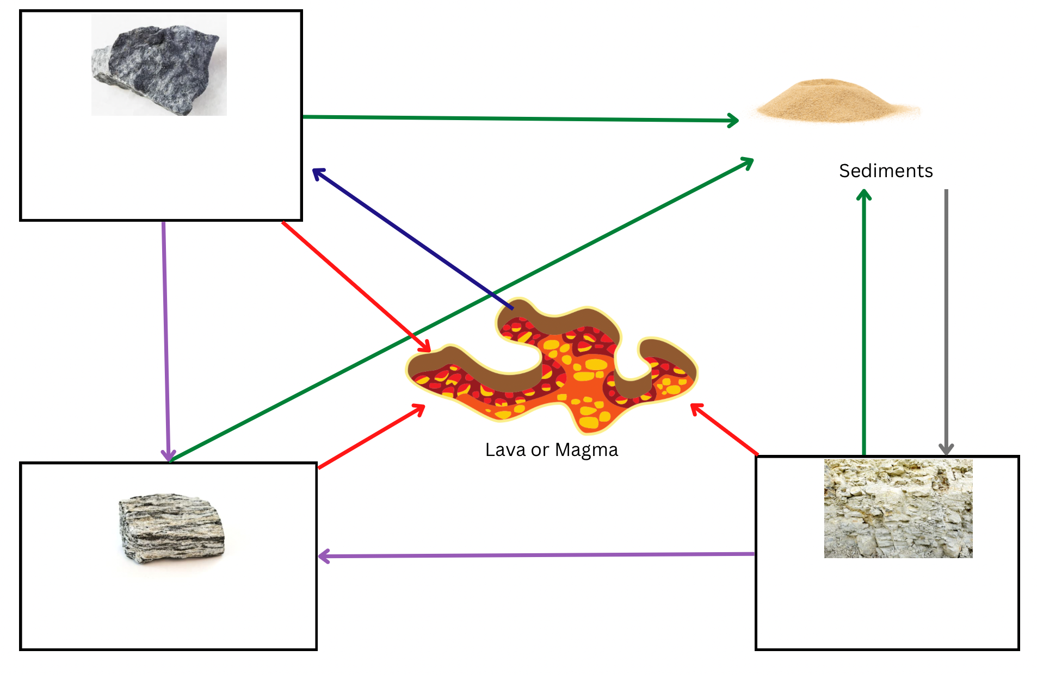
- Complete the rock cycle diagram below.
______________________
_________________________
_________________________
- In each of the boxes, enter the type of rock. (3m)

- Complete the table by labelling each of the processes indicated by the arrow in the diagram above. (5m)

Coloured arrow | Name of process
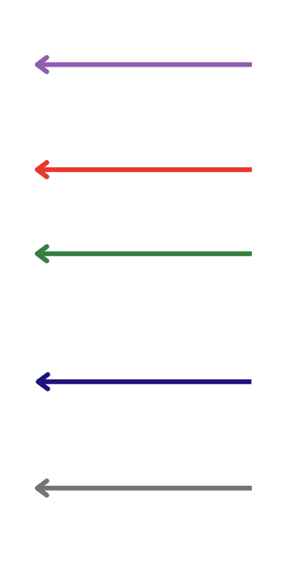

- Label the following rocks with either metamorphic, sedimentary or igneous. (5m)
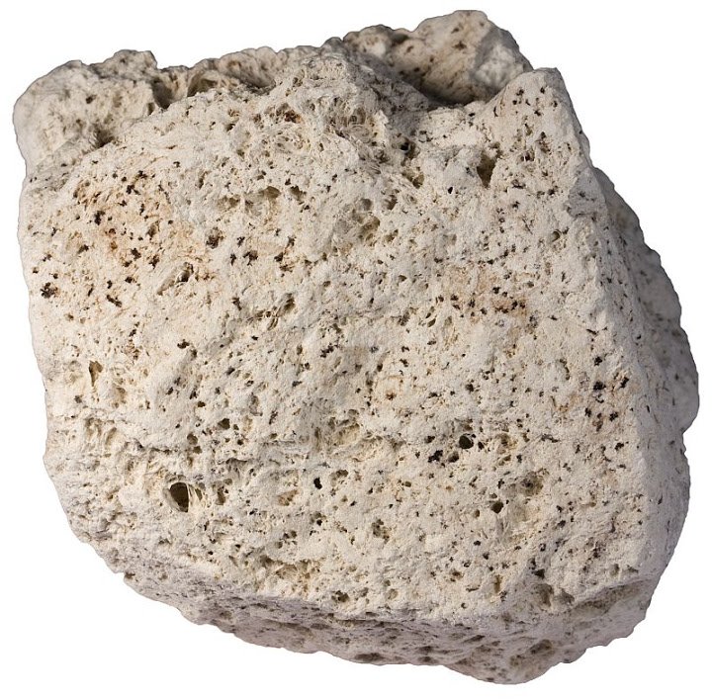
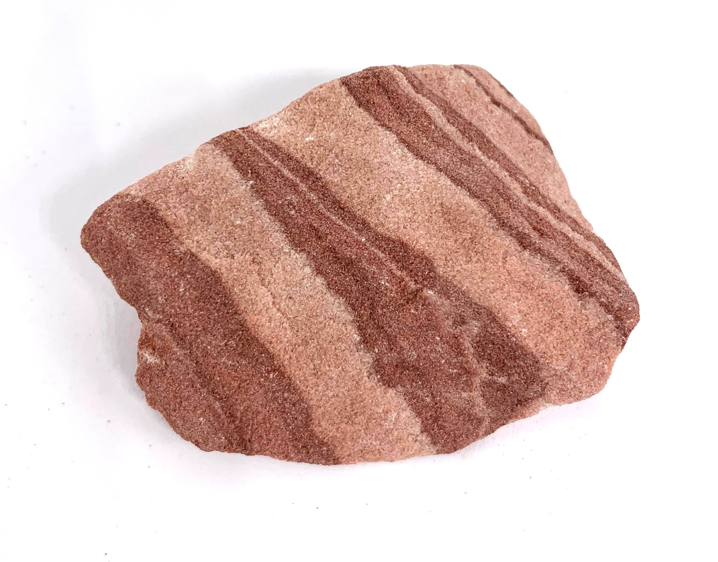

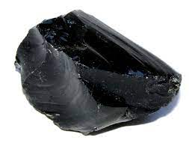
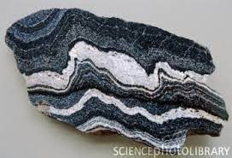

____________________ _____________________

- What is the difference between lava and magma? (1 m)

_________________________________________________________________________________________________________________________________________________________________________________________________________

- Use the following pictures to answer questions a and b.
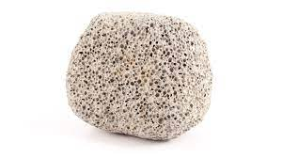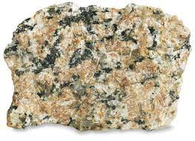
B
A

- Which rock is intrusive? (1m)
____________________________________________________________
- Which rock cools quickly? (1m)
____________________________________________________________
- Explain how you made your decision in b). (1m)
____________________________________________________________

- Distinguish (tell me the difference) between weathering and erosion. (2m)
_________________________________________________________________________________________________________________________________________________________________________________________________________

- Distinguish (tell me the difference) between rocks and minerals. (2m)
_________________________________________________________________________________________________________________________________________________________________________________________________________

- An archaeologist was on a dig in Australia. She came across a number of fossils as shown below.

- Which fossil is the oldest? (1m)
________________________________________________________________

- Explain why you gave your answer in part a). (1m)

________________________________________________________________
________________________________________________________________
- What rock type would she have been digging in? Why? (2m) ________________________________________________________________
________________________________________________________________

- You have been asked to select a building material for a new construction and have narrowed the choice down to three minerals. Your final decision will be based on which of the minerals is the hardest.
Describe the steps you would use to determine the hardest mineral, without looking them up on the Moh’s scale. (5m)

_________________________________________________________________________________________________________________________________________________________________________________________________________
_________________________________________________________________________________________________________________________________________________________________________________________________________
_________________________________________________________________________________________________________________________________________________________________________________________________________
_________________________________________________________________________________________________________________________________________________________________________________________________________
_________________________________________________________________________________________________________________________________________________________________________________________________________

Section B: Rock Cycle Practical _________ / 24 Marks

Student Name: ____________________________

Materials:
- 1 Cube of sugar
- 10 cm² Foil
- 10 cm² White paper
- Candle
- Hand Lens
- Wooden test tube peg

Step 1: Examine the sugar cube with a hand lens

Observations - Describe what you see by completing the boxes below. |  | ___ / 3 Marks  ½ mark each
Grain size

Grain shape

How close the grains are?
Are the grains cemented together?

Overall shape of the sample
State of Matter (Solid, liquid, gas)

Conclusion - Relate your observations to the Rock Cycle | ___ / 3 Marks
What rock type does this represent?  Explain why. | ___ / 1 Mark  ___ / 2 Marks
Step 2: Place sugar cube on white paper square and use the back of the tongs to crush part of the cube into a powder.

Observations - Describe what you see by completing the boxes below. |  | ___ / 3 Marks  ½ mark each
Grain size

Grain shape

How close the grains are?
Are the grains cemented together?
Overall shape of the sample
State of Matter (s,l,g)

Step 3: Fold the edges of the foil over to make a small bowl. Pour the crushed sugar into the foil bowl.

Conclusion - Relate your observations to the Rock Cycle | ___ / 2 Marks
What process in the Rock Cycle does the movement from place to place, of the crushed sugar represent?  Explain why and how: | ___ / 1 Mark  ___ / 1 Mark

Step 4: Use the metal tongs to hold the bowl over the candle flame. Write down what your observations are as the sugar begins to melt.

Observation - Relate your observations to the Rock Cycle | ___ / 3 Marks
What process in the Rock Cycle does this replicate?  Explain how this comes about in the Rock Cycle: | ___ / 1 Mark  ___ / 2 Marks

Step 5: Set the foil bowl aside and let the sugar cool and harden. Write down what your observations are as the liquid begins to cool.

Observations - Describe what you see by completing the boxes below. |  | ___ / 1 Mark  ½ mark each
Grain present?

Overall shape of the sample

Observation - Relate your observations to the Rock Cycle | ___ / 3 Marks
What process in the Rock Cycle does this replicate?  Explain how this comes about in the Rock Cycle: | ___ / 1 Mark  ___ / 2 Marks

Step 6: Break the hardened sugar into pieces by crumpling the cooled foil a little. Write down what your observations are as the sugar begins to break up.

Observation - Relate your observations to the Rock Cycle | ___ / 6 Marks
What process in the Rock Cycle does this represent?  What is produced from this process in the Rock Cycle?  What do you notice about what you did in step 2, and what you did in step 6?  What does this say about the rock cycle and the paths a rock can take? | ___ / 1 Mark  ___ / 1 Mark  ___ / 2 Marks  ___ / 2 Marks

